**Chat Application Documentation**

This document contains screenshots of how the chat application works.

**Start Screen**

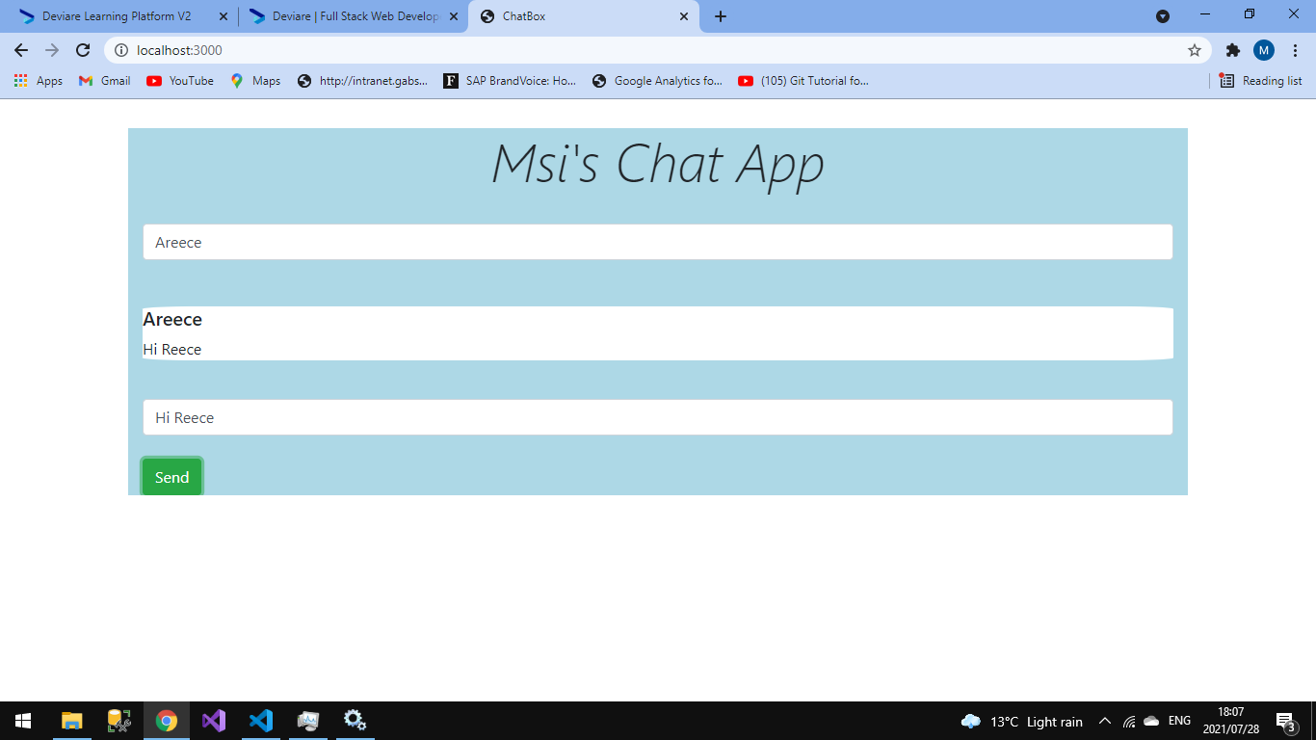

**Chats**

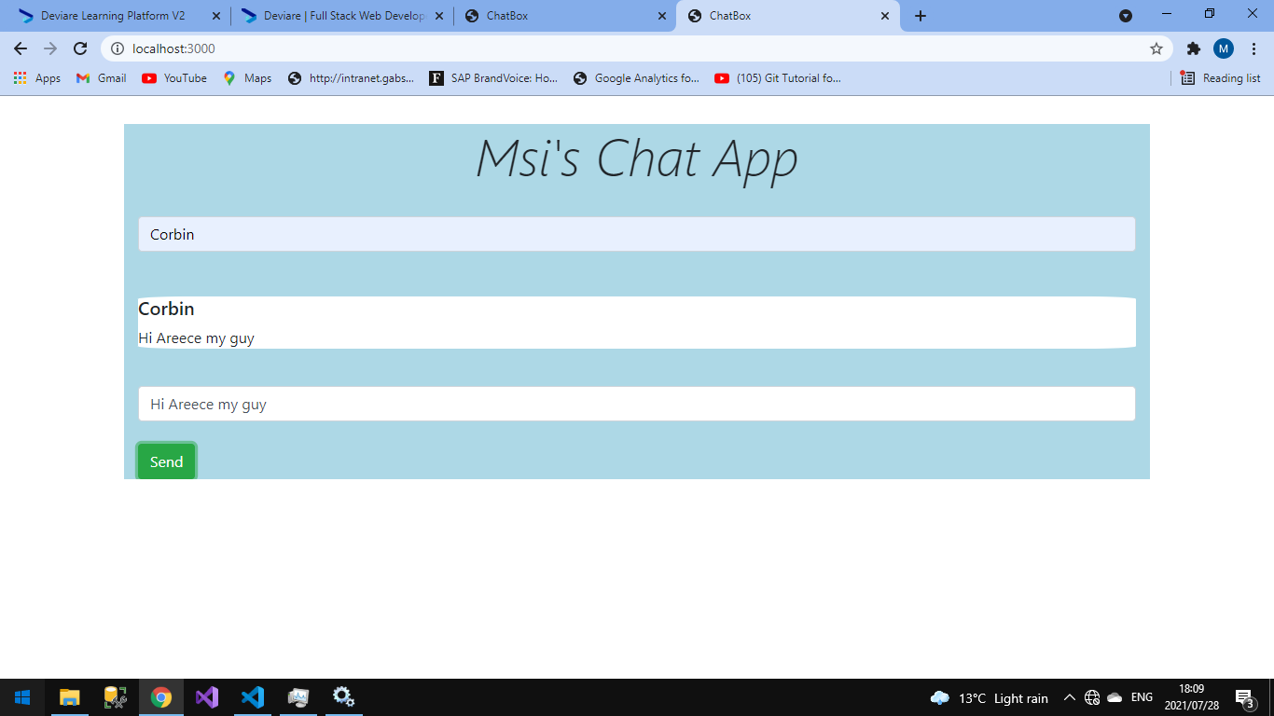

**Chats between two people**

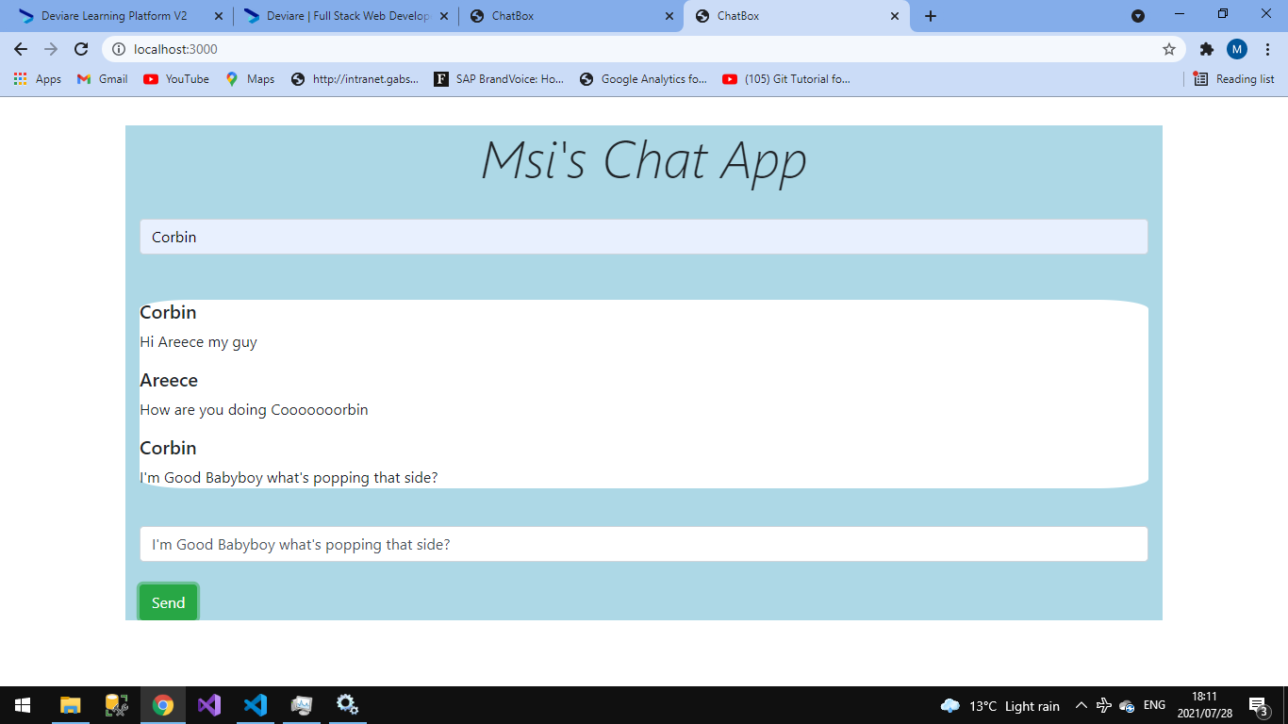

**Chats**

